**Project title:**

A mixed traffic simulation model.

**Release note:**

Release 1.0 (04/08/20)

**Getting Started:**

The mixed traffic simulation model consists of connected autonomous vehicle and human driven vehicle car following and lane changing control components, and it can be used to investigate the impacts of connected autonomous vehicle lane changing behavior on traffic performance.

**Prerequisites:**

Requires:

Microsoft Visual Studio 2017 or higher

PTV VISSIM 11

**Installing:**

1. **Generate CAV and HV control and output DLL**
2. generate CAV control and CAV trajectory output DLL

Open and run “**DriverModel.vcxproj**” in Microsoft Visual Studio, which is located at \source code\DriverModel_DLL_CAV

1. generate HV trajectory output DLL

Open and run “**DriverModel.vcxproj**” in Microsoft Visual Studio, which is located at \source code\DriverModel_DLL_HV

1. **Import generated DLLs into PTV VISSIM**
2. Open I-75.inpx using PTV VISSIM
3. Right click on the AV row highlighted in red below and then click “Edit”

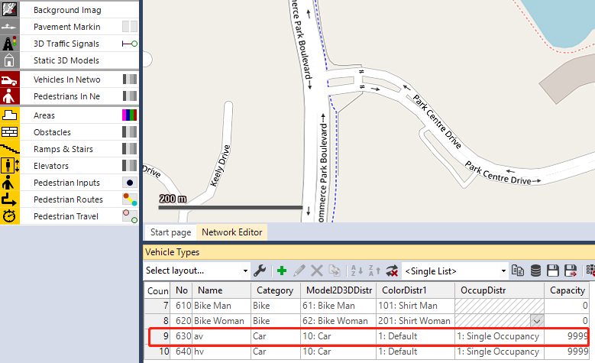

1. Click “External Driver Model” and locate the DLL generated in Step 1.a.

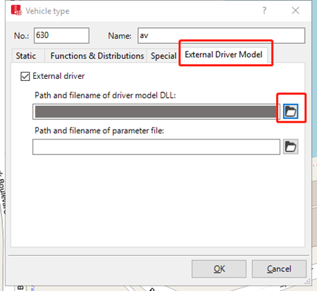

1. Right click on the HV row highlighted in red below and then click “Edit”

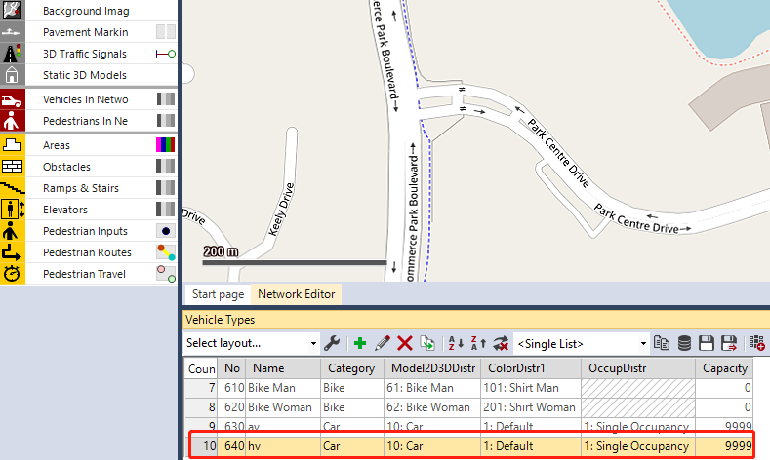

1. Click “External Driver Model” and locate the DLL generated in Step 1.b.

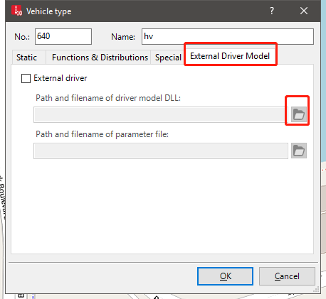

**Testing:**

1. **Run the simulation in PTV VISSIM.**
2. **After the simulation (5 minutes), CAV and HV trajectory information will be generated and saved in data_put_out_AV.txt and data_put_out_HV.txt.**